Problem Sheet – III(19PW13)

Create an employee table with attributes employee number, first name, last name, and designation, manager ID as MGR, date of birth, hire date, salary and commission. Enforce the following constraints on employee table:
Employee number is primary key, first and last names should not be null, Manager number will be the foreign key which refers primary of this table; date of birth must be less than or equal to 1980; Salary is less than Rs.1, 00,000/- and greater than Rs.20, 000/-.

ENO | FNAME | LNAME | DESIG | MGR | DOB | HDATE | SALARY Rs. | COMM. Rs.
101 | Janson | Hass | President |  | 12/09/1973 | 12/01/2003 | 87,500.00
110 | James | Thompson | Manager | 101 | 06/01/1973 | 25/02/2008 | 52,950.00
115 | Celia | Geyer | Manager | 101 | 07/09/1972 | 17/09/2007 | 46,850.00 | 22,530.00
117 | Robert | Stern | Manager | 101 | 04/02/1972 | 15/03/2006 | 49,900.00 | 20,555.00
135 | Linda | Pulaski | Salesman | 110 | 29/08/1968 | 19/09/2007 | 21,250.00 | 14,500.00
142 | David | Henderson | Salesman | 110 | 02/02/1970 | 23/03/2006 | 21,700.00 | 12,400.00
167 | Martin | Spenser | Salesman | 110 | 09/02/1971 | 28/07/2005 | 27,000.00 | 16,600.00
172 | Smith | Nicholls | Clerk | 110 | 12/03/1965 | 26/04/2003 | 21,850.00
154 | Larry | Adamson | Salesman | 110 | 02/02/1974 | 18/02/2004 | 22,250.00 | 17,000.00
179 | Mathews | Pinka | Analyst Manager | 117 | 08/01/1975 | 23/04/2008 | 35,000.00
183 | Sally | Brown | Clerk | 179 | 29/08/1968 | 14/07/2008 | 21,250.00
190 | Christine | Jones | Analyst Manager | 117 | 13/09/1968 | 05/09/2005 | 34,000.00
199 | Michael | Parker | Clerk | 190 | 07/02/1971 | 17/03/2004 | 21,600.00
200 | John | Mehta | Clerk | 115 | 02/03/1975 | 12/02/2006 | 21,350.00
137 | Bruce | Wong | Salesman | 110 | 12/12/1976 | 18/10/2005 | 22,250.00 | 13,000.00

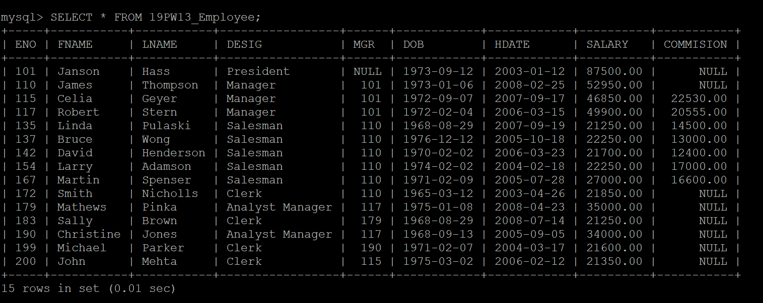
- List the details of all the employees who are younger than the employee with employee number 167.
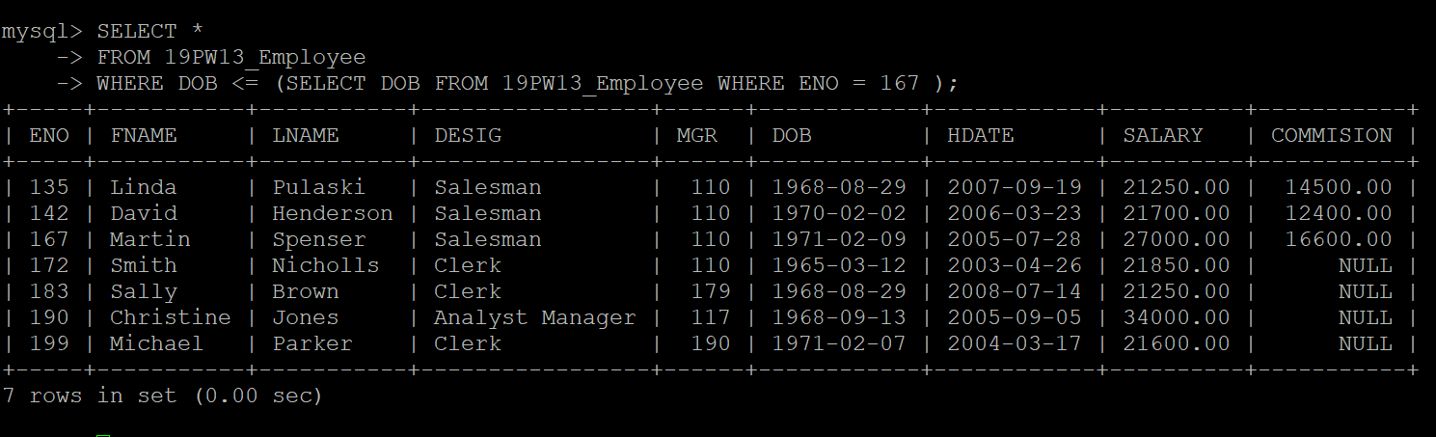

- Display first and last names all the employees who are less than 30 years old.
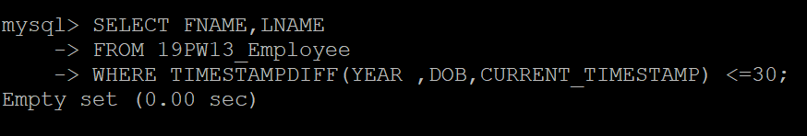

- Display the details of employees whose last name contains the consecutive letters ‘er’.
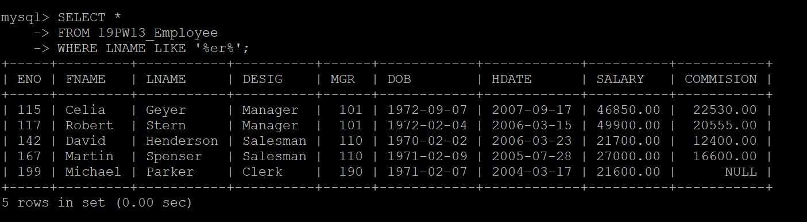
- Display the names of emplyees whose first name starts with ‘M’ or ‘J’.

- Display first name, last name and salary of all the employees with the designation “Analyst Manager” or “Manager”.
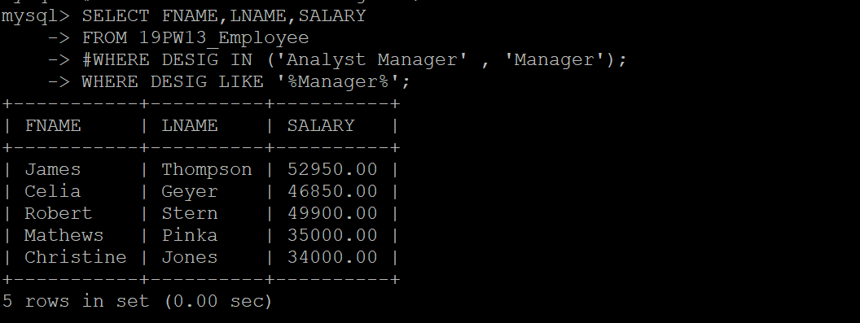

- Display the details of employee(s) who is (are) eldest in the employee table.
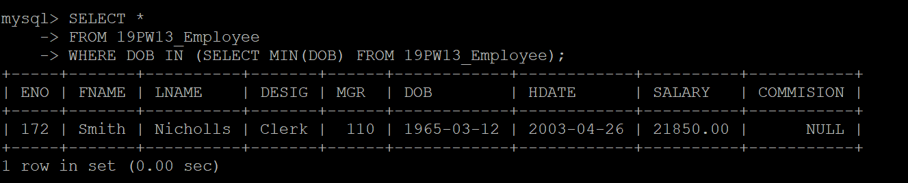

- List out the employees who all are not manager and analyst.
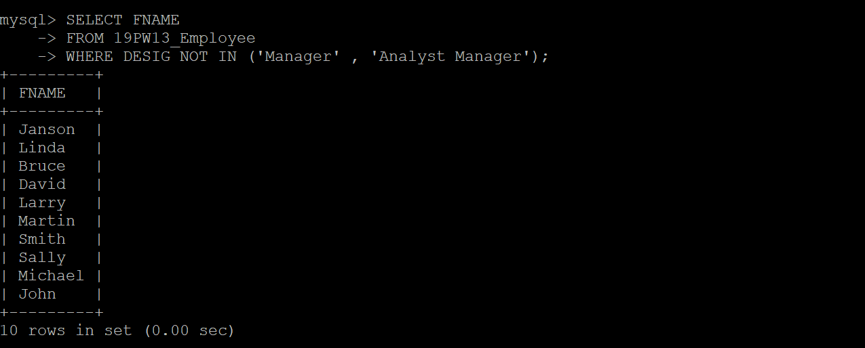

- Display the details of employees with a salary over Rs.35, 000.00 and born in between 1966 to 1976.
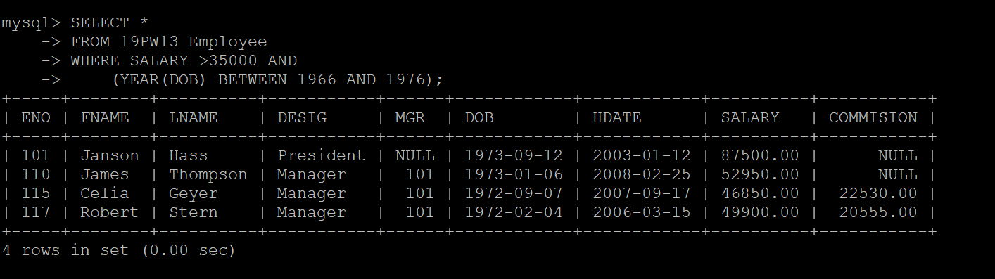

- Display the employee number, first name, last name, designation and salary whose salary is greater than or equal to Rs.35,000.00 and the job title is “Analyst” or “Manager”

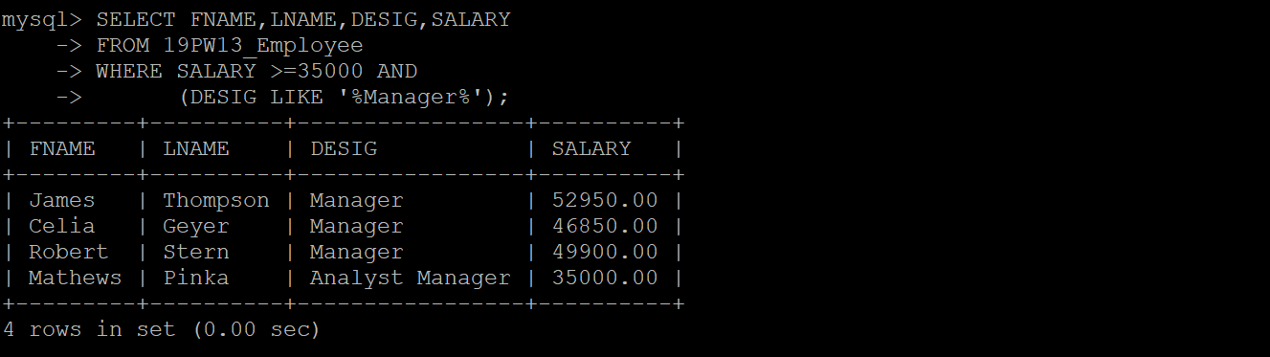

- Display the employee number, first name, last name, designation and salary of employees whose commission is greater than or equal to Rs.15,000.00 and designation is ‘Salesman’ or ‘Manager’.
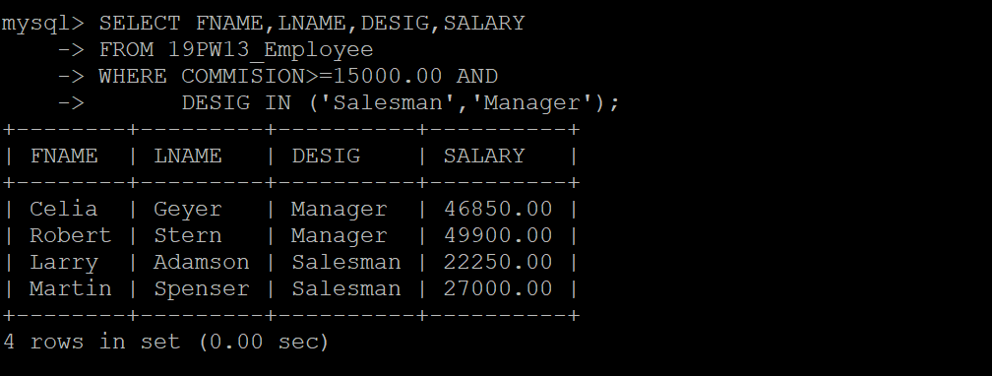

- Display the total number of employees in each job title.
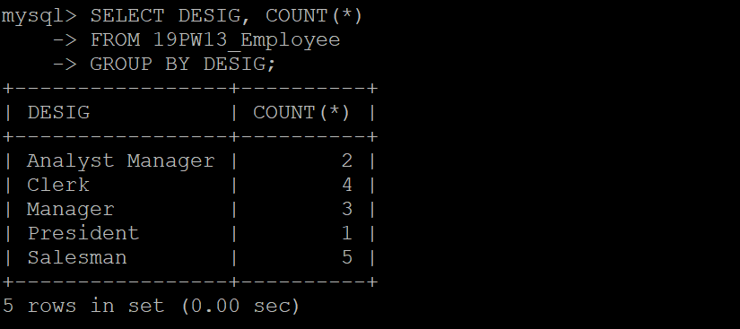

- Display the employee number, last name, Salary of employees whose last name is in the list, ‘Thompson’, ‘Spenser’, ‘Geyer’, and ’Brown’, ‘Jones’.
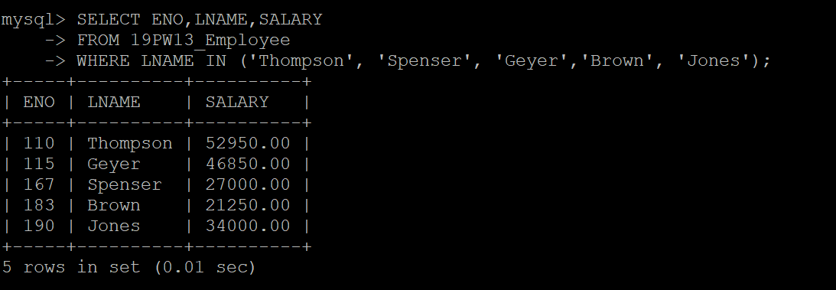

- Find out and display the total number of employees joined in every year.
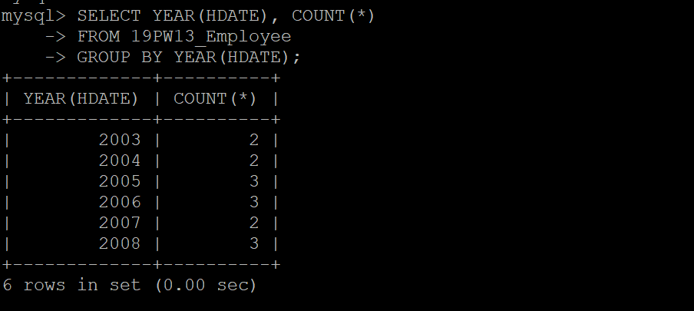

- Display the employee ID, last name, salary and age of employees whose age is in between 30 and 40.
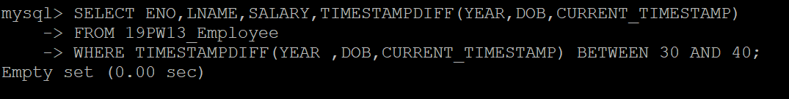

- Find out and display the first name employees who all are managed by ‘James’ or ‘Robert’ or ‘Celia’.
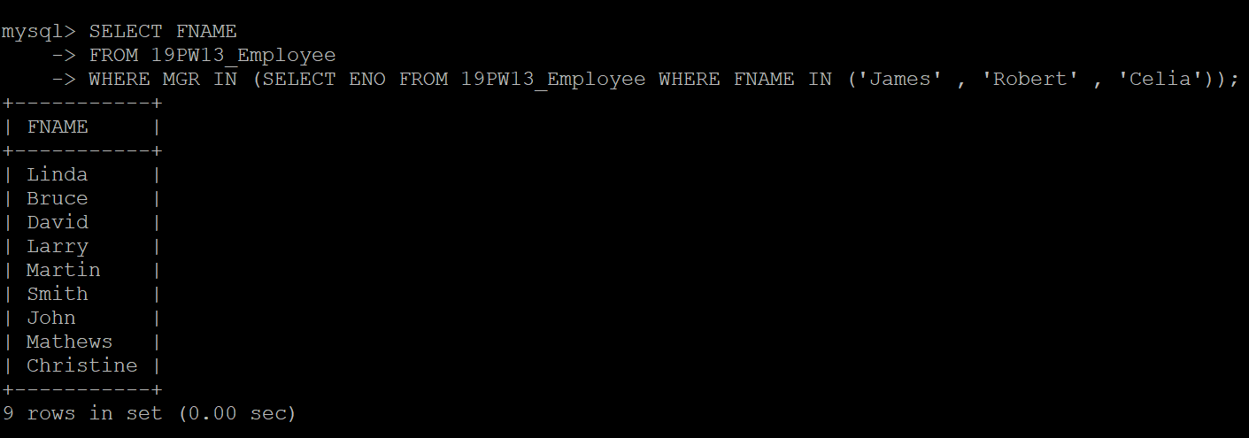

- Display all the employees with their fist name, last name and designation as follows
“First name“, “last name”, “designation”.
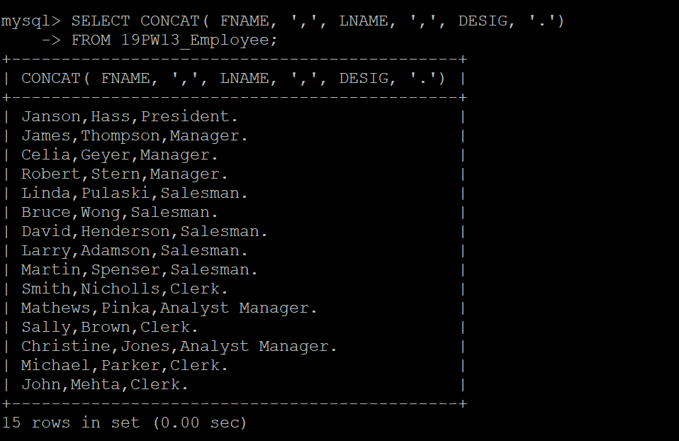

- Find out the employee who is youngest earning commission.
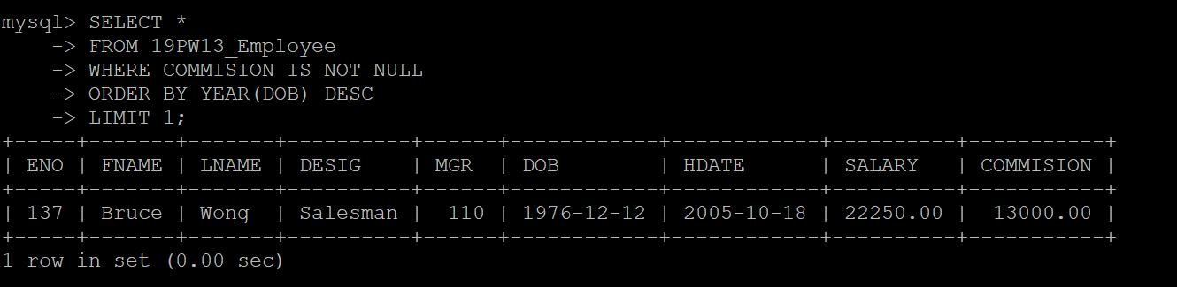

- Display all the employees with their date of birth and date of joining as follows.
Example: Dear ‘James ’, you were born on 06, Monday – September – 1972’.
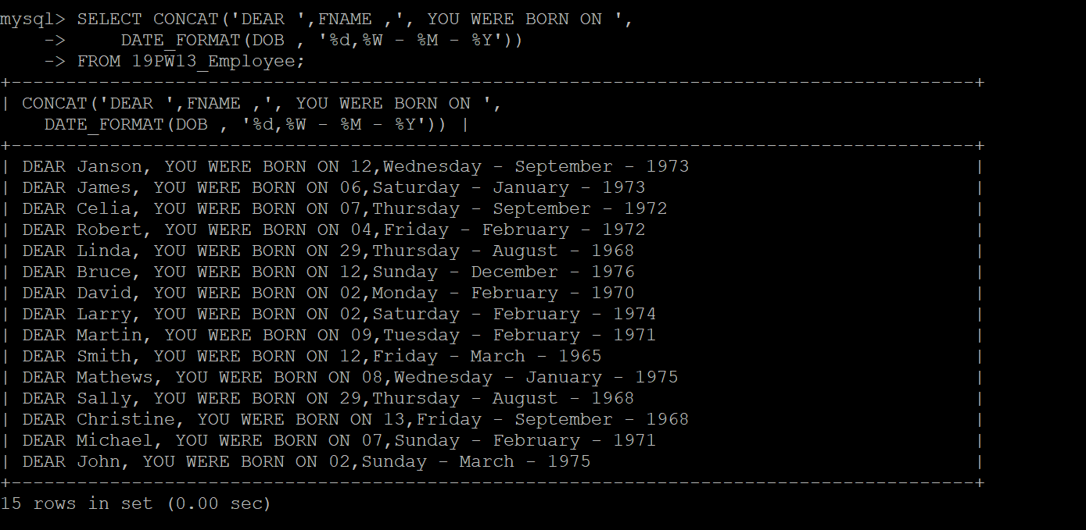

- Display the employees who are all getting maximum salary in each job title.
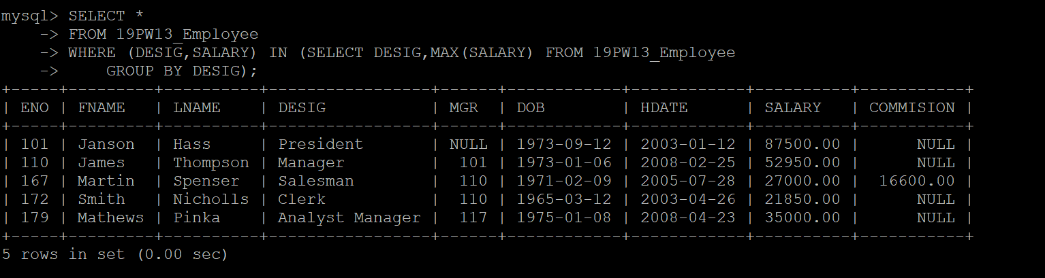

- Display the employee number, first name and salary of employees who were born in either January or February or August.
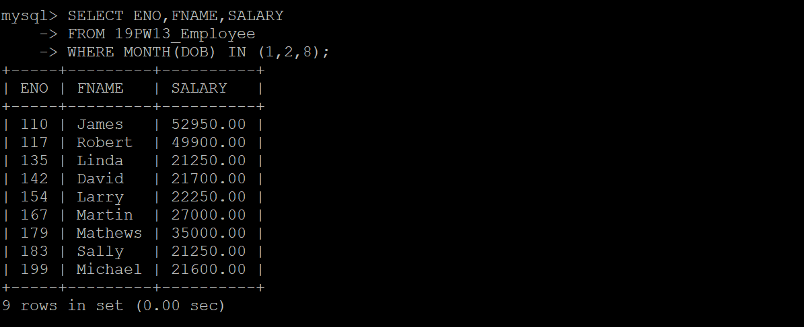

- Display the name, salary, commission and total remuneration (salary + commission) of all the employees.
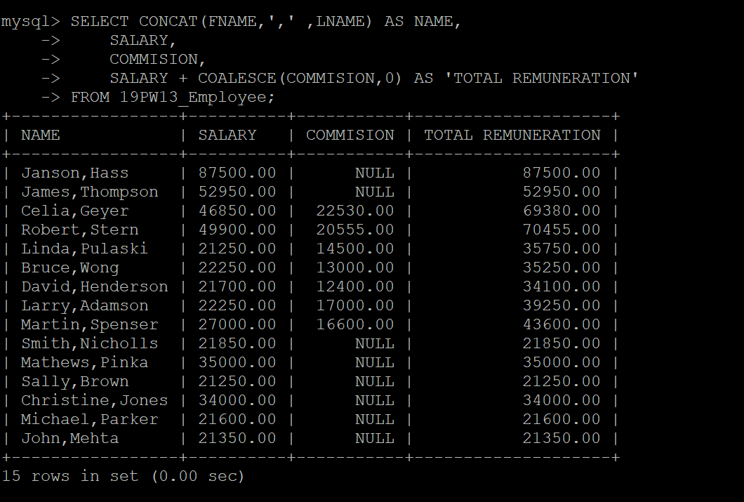

- Display the first name, salary, commission and total remuneration for all the employees and fill the column with 0 for those who do not have any commission in the commission column.
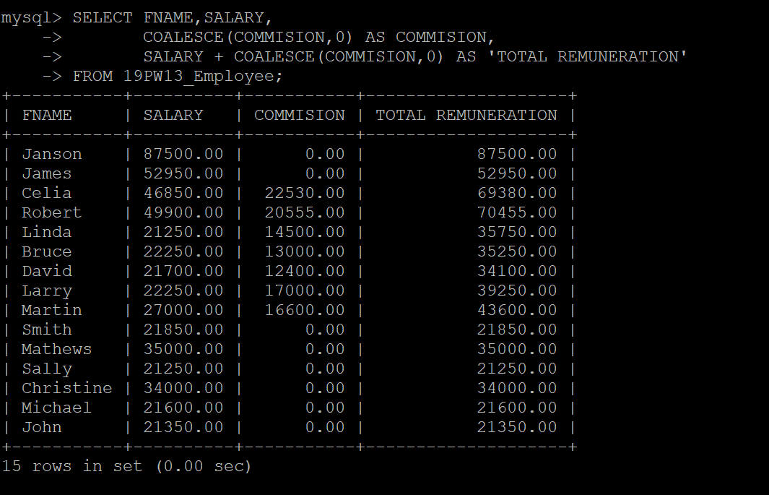

- Display first name of all the employees having maximum experience in each designation.
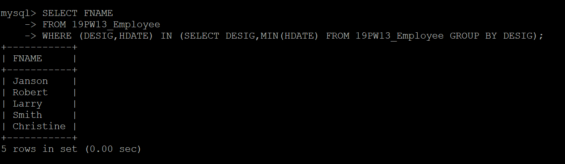

- Display the details of all the managers getting salary greater than Rs.40, 000.00 and born before 1973.
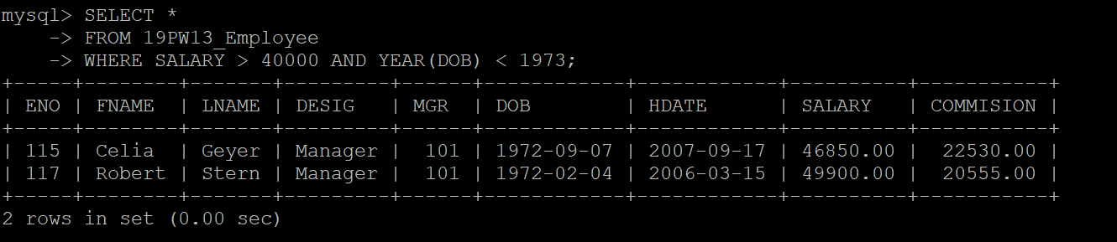

- Display all the details of employees who are not getting any commission but getting salary between Rs25,000.00 and Rs35,000.00.
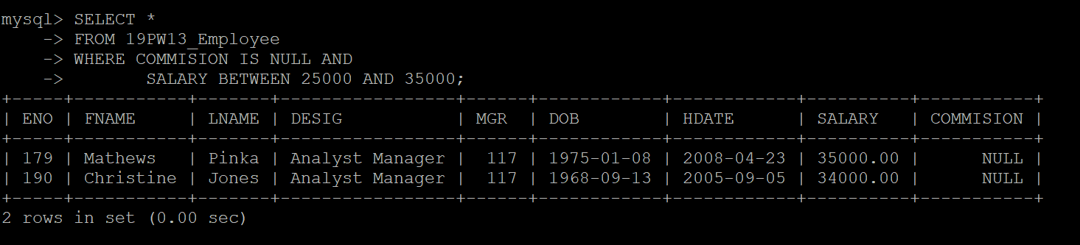

- Find and display the details of all the employees whose born and joined month are same.
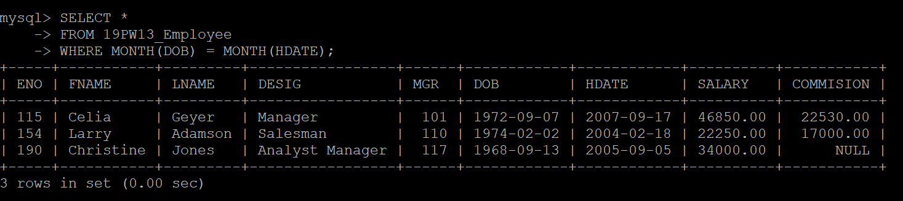

- Display the employee number and first name of all the employees with hire date in the format like February 22, 1991.
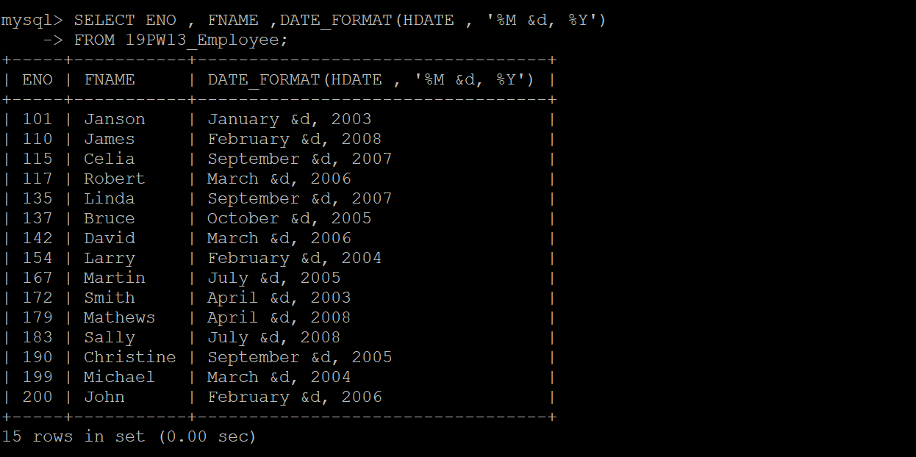

- Display the employee number, name, designation, hire date, and experience of all the managers.
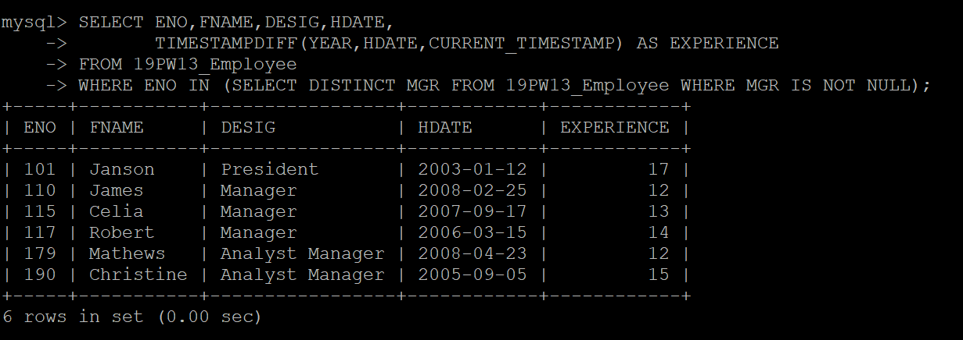

- List the employee ID, name, salary of all the 'Managers' and 'Analyst' with more than 5 years of experience and not receiving any commission. Display the list in ascending order the employee number.
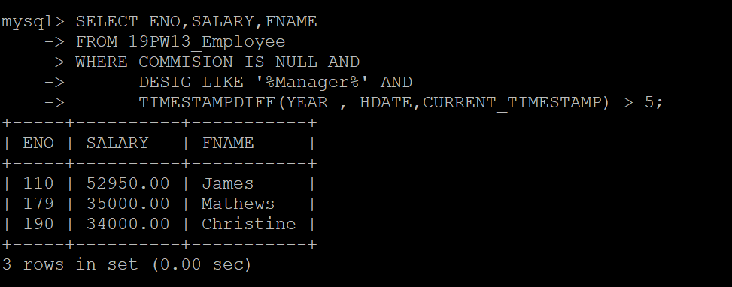

- List the employees who are senior to ‘Martin’.
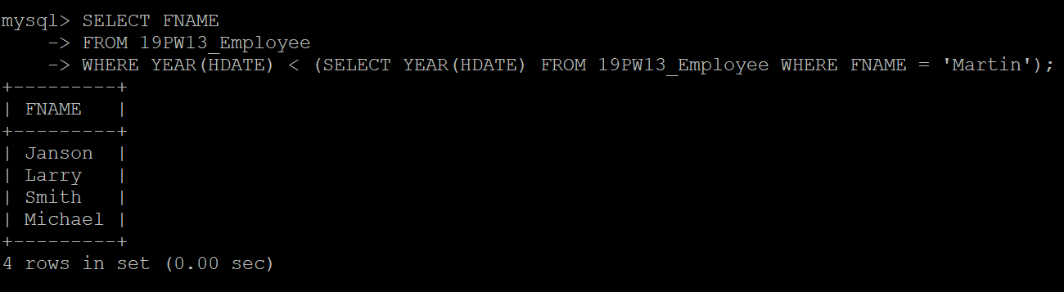

- Display the first names of all the employees whose salary is same as the salary of ‘Larry’.

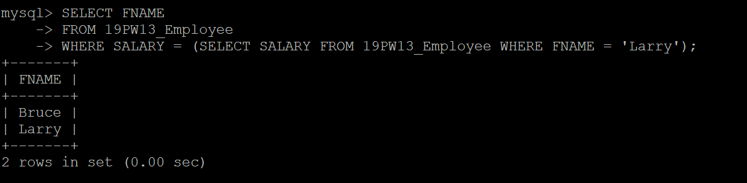

- Display the names of employees whose designation is same as the designation of ‘James’ or salary is more than the salary of ‘Celia’.

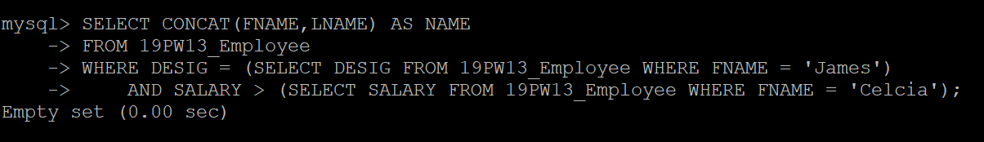

- Find and display the details of the highest paid employee(s).
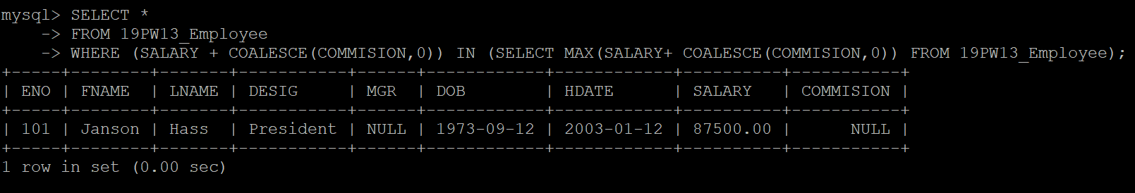

- List the details of employees who have been hired most recently as ‘salesman’.

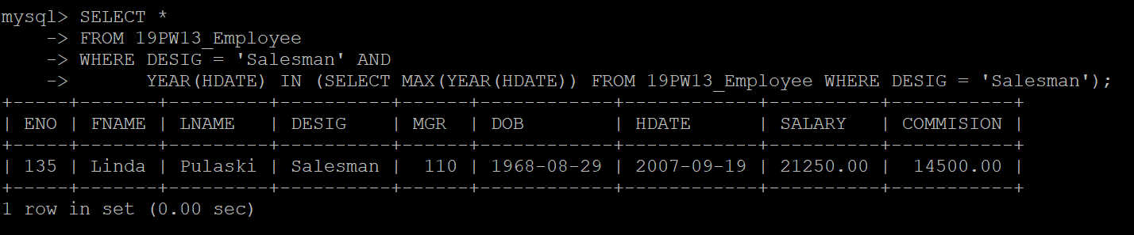

- List the employees who are senior to the most recently hired employees working under employee id 110.
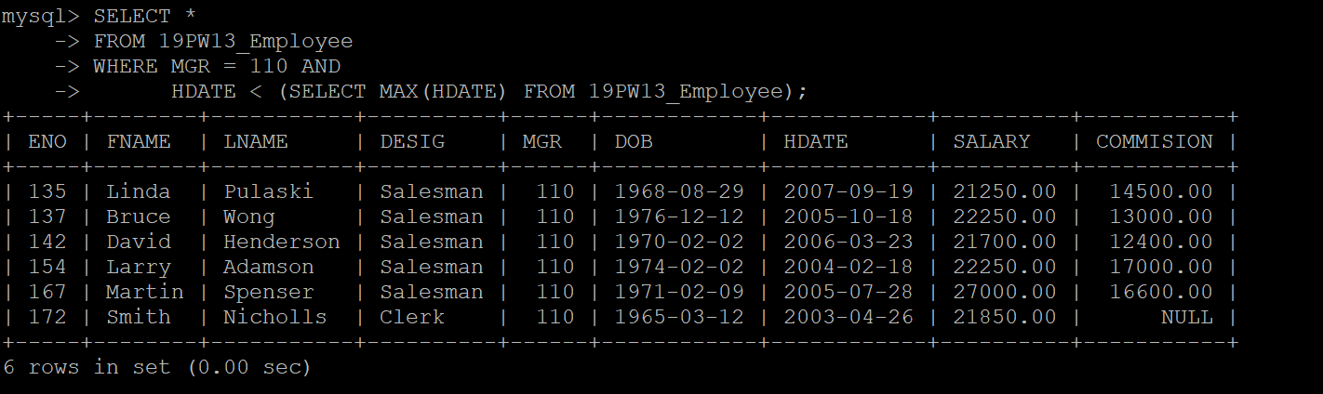

- Find and display the details of the senior employees as on year 1991.
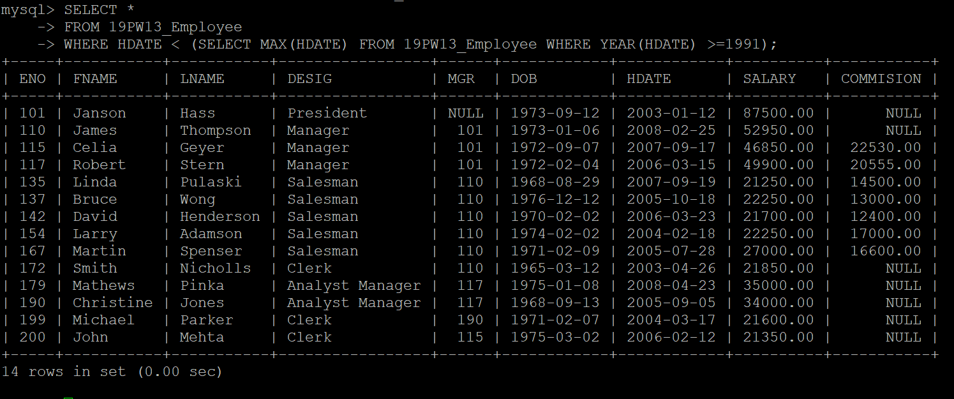

- List the employees’ names whose salary is equal or more to the average of maximum and minimum salary.
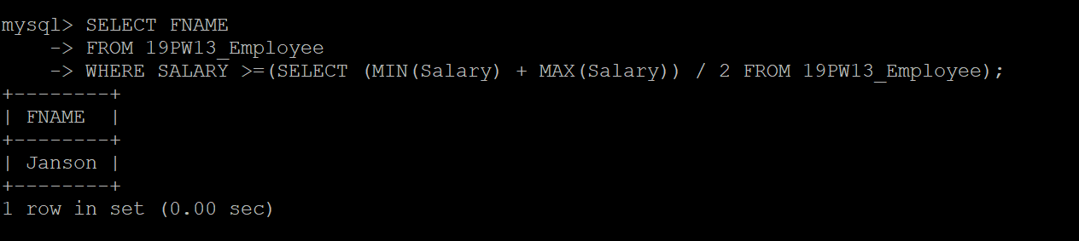

- Write a query to find and display the names of the least 5 earners of the company.
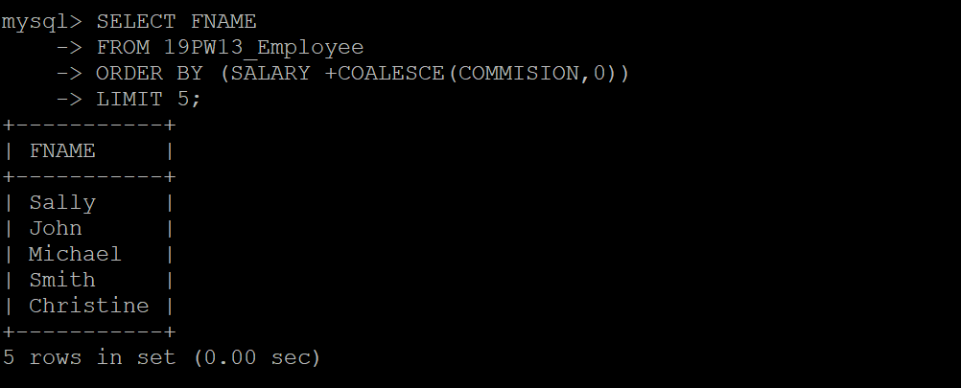

- List the name, salary, commission and netpay for those employees whose netpay (salary + commission) is more than any other employee.
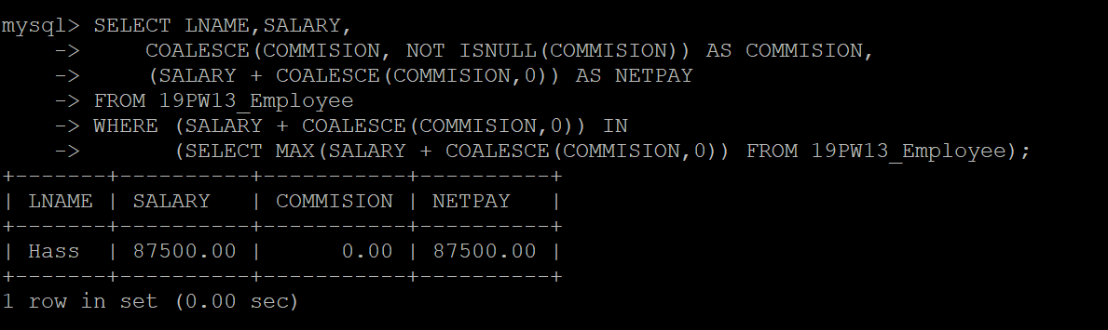

- Display the names of employees who joined the company on the same date.


- Display the employee numbers of employees who are not working under any managers.


- List the names of the managers who are having maximum number of employees working under him.
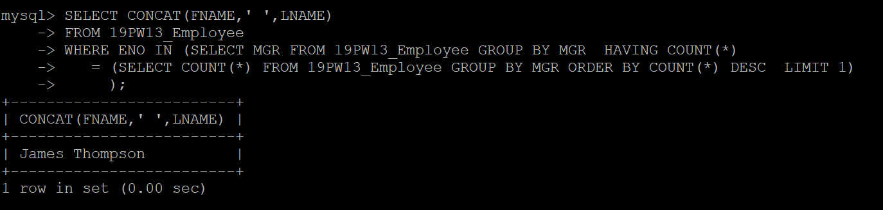

- Find and display the details of the most recently hired employees in each department and order by hire_date.
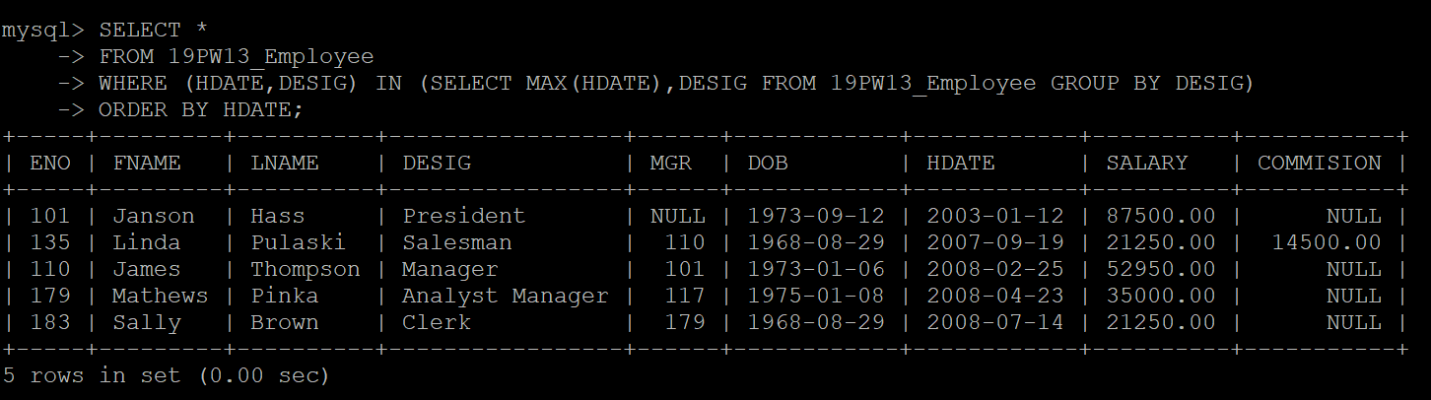

- Find the name and designation of the employees who earn a commission and salary is the maximum.


- List the details of employees who are getting same salary.
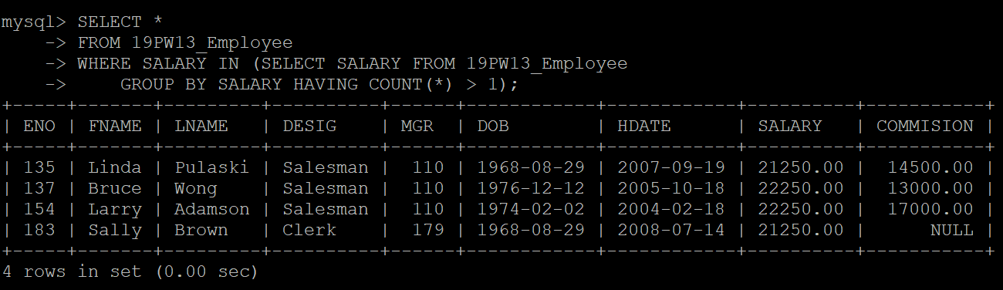

- Find and display the maximum of the average salary drawn for each designation except for President.
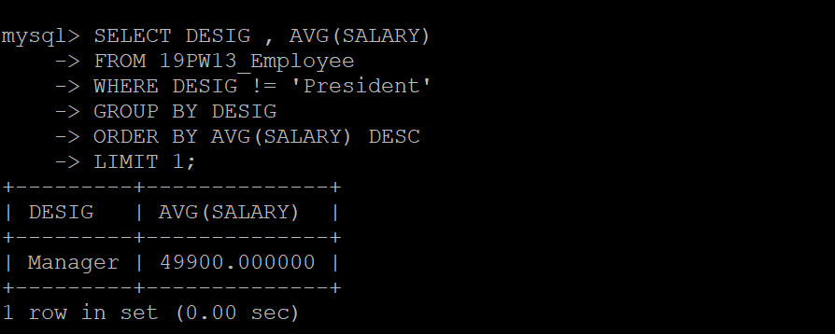

- Display the employee numbers of employees who are not managing other employees.
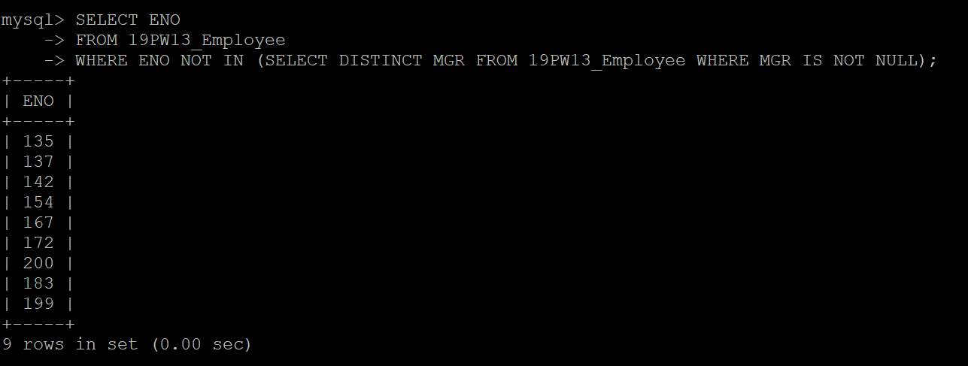

- Display the total remuneration (salary + commission) of all employees working under the manager number 110.
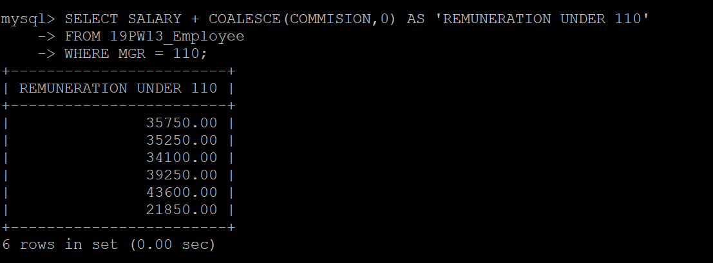

- Update the commission column with 10% increase in salary for the employees whose birthday falls in the current month.


- Remove all the employees who are earning more than Rs. 40,000/- as their salary except ‘president’ and ‘manager’.



